CALL FOR SUBMISSIONS:
Community engagement for inclusive rural transformation and gender equality
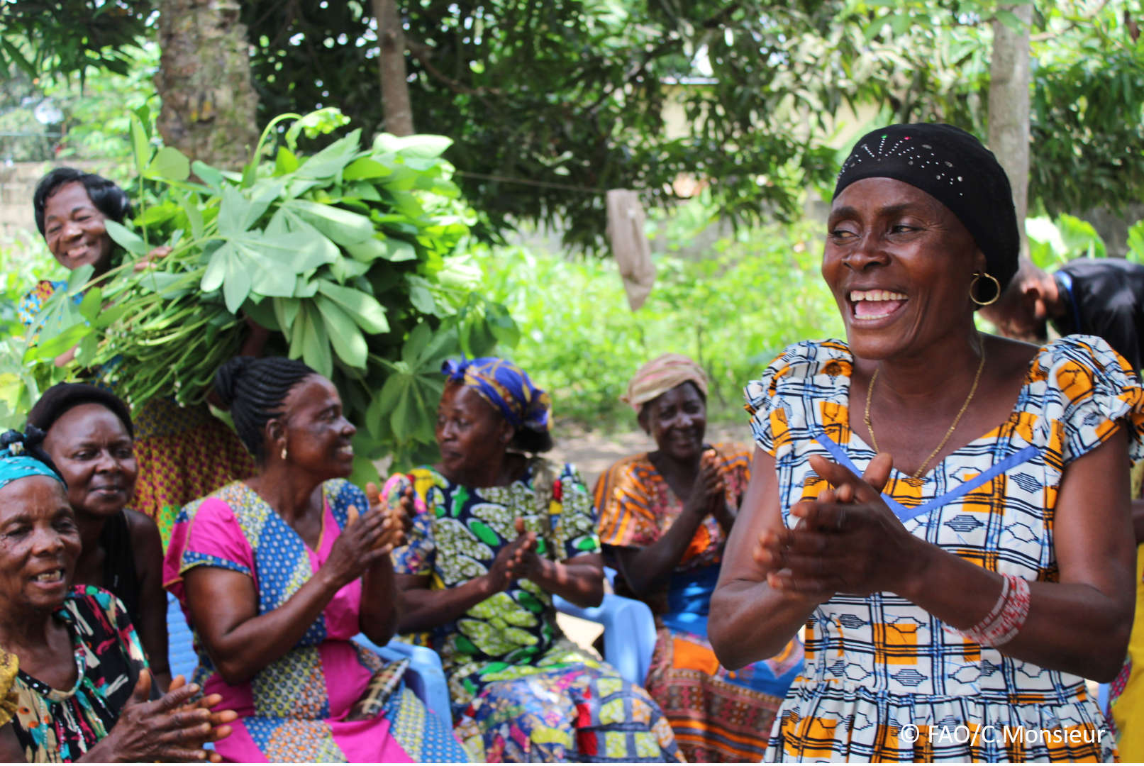
The objective of this call for submissions is to collect good practices, experiences, and lessons learnt on the use of community engagement for inclusive rural transformation and gender equality. The initiative, organized by the Rural Transformation and Gender Equality Division (ESP), seeks to gather insights from a diverse range of contributors, both within FAO and from external stakeholders. Its goal is to share knowledge, foster learning, and guide the scaling up of community engagement and community-led collective action to leave no one behind. The call builds on FAO's past efforts in this area, such as the Community Engagement Days series of webinars.
The call for submissions is open until 27 November 2024.

How to take part in this call for submissions:
To take part in this Call for submissions, please register to the FSN Forum, if you are not yet a member, or “sign in” to your account. Please review the topic note to understand the criteria we are considering for this call. If you wish to learn more about community engagement, you may refer to the background document. Once you have completed this submission template, upload it in the box “Post your contribution” on the call webpage, or, alternatively, send it to fsn-moderator@fao.org.
Please keep the length of submissions limited to 1,500 words and feel also free to attach relevant supporting materials.

Template for submissions

Contact person | Name: Agbebi F.O. and Bamigboye E.O.  Organization/Unit: Olusegun Agagu University of Science and Technology/ Fishery Extension  Country: Nigeria  Email address: fo.agbebi@oaustech.edu.ng
Name/title of the good practice | Integrating community and conventional Approaches to Climate change mitigation among crop Farmers in Nigeria
Where is the good practice taking place? (Multiple selection allowed) | ☐ Europe and Central Asia  ☐ Latin America and the Caribbean  ☐ North Africa and Near East  ☒ Sub-Saharan Africa  ☐ Asia and the Pacific  ☐ North America  ☐ Global
Affiliation | ☒ Farmer and producer organizations  ☐ Trade Union  ☒ Informal community-based, farmer-based or self-help group  ☒ Research and academia  ☐ Government  ☒ Local/traditional authorities  ☐ Private Sector  ☐ Civil Society Organization  ☐ Intergovernmental Organization (e.g. UN system, World Bank)  ☐ Resource Partner/Donor  ☐ Other (please specify)
In which sector(s) and context (s) have you used this community engagement good practice? (Multiple selections allowed) | ☐ Education  ☐ Health and Sanitation  ☒ Food production in agrifood systems (please also tick the sub-categories)  ☒ Crop cultivation  ☒ Fisheries and aquaculture production  ☐ Livestock  ☐ Forestry  ☒ Agroforestry  ☐ Horticulture  ☒ Apiculture (beekeeping)  ☒ Agroecology and sustainable farming practices  ☐ Soil and water management  ☐ Other: ____________  ☐ Post-production in agrifood systems (please also tick the sub-categories)  ☒ Processing and value addition  ☒ Marketing and retailing  ☐ Transporting  ☒ Food loss and waste  ☒ Packaging  ☒ Storage  ☐ Distribution  ☐ Other _______  ☒ Gender Equality  ☒ Climate Action  ☐ Citizenship and Governance  ☐ Social Protection  ☐ Humanitarian and protracted crisis  ☒ Conflict resolution, peace and resilience  ☐ Digital innovation  ☐ Other sector (please specify) _________
Who are the financial partners supporting this good practice, if applicable? | Tertiary Education Trust Fund (TETFUND), African Women in Agriculture and Rural Development (AWARD)
- In a few sentences, summarize your community engagement good practice.
Effective community engagement relies on creating awareness to mobilize resources and stakeholders. Building confidence is essential for fostering trust and collaboration. Engaging key actors through transparent feedback ensures accountability and project relevance. Finally, sustainability is achieved by maintaining continuous and inclusive engagement efforts.
- What problem(s) or challenge(s) does your good practice aim to address through community engagement? ‘
The good Practices listed for community engagement aim to address problems and challenges are;
- Barriers to effective communication
- Innovation adoption rents
- Lack of appropriate participation
- Poor resources mobilization
- Poor sustainability of Initiatives

- Describe your good practice in more detail. Include the main guiding principles, the desired changes or outcomes you aim to achieve (Theory of Change), and the key phases of implementation.
This good practice emphasizes sustainable community engagement built on inclusivity, empowerment, and accountability. It seeks to foster resilience, active participation in decision-making, and the inclusion of marginalized voices.

Desired Outcomes:
Promote gender equality.
Amplify representation of minority groups.
Strengthen social cohesion.
Establish feedback systems to adapt to challenges.

Implementation Phases:

1. Planning and Assessment: Identify community needs and set objectives through stakeholder engagement.

2. Capacity Building: Provide training to develop leadership and management skills among community members.

3. Action and Participation: Implement activities that prioritize inclusive involvement.

4. Monitoring and Feedback: Continuously evaluate progress and adjust based on community input.
- Who are the key actors and stakeholders involved in the design and implementation of the good practice, and what are their respective roles? Consider local partners, government, local authorities, community radios, civil society, research, the private sector, etc.
In the design and implementation of community engagement of the good practices, several key actors and stakeholders are involved and each played important roles. Some of the key actors/ stakeholders and their roles are defined here;
Farmers, including all the participating and contact farmers in the community
Roles: Resources and group Mobilization, end users of research products
Extension agents: They are the link between local famers and research institutions
Researchers- Designing of research for the community
Government Agency: Play a crucial role in incentives for community engagement activities
Security Agency: They secure lives and support for community engagement.
- How does your intervention ensure inclusivity and equal and meaningful participation within the community?
Ensuring Inclusivity and Equal Participation:
The intervention engaged diverse demographic groups by tailoring strategies to factors like gender, age, ethnicity, disability, and socio-economic status. Special attention was given to vulnerable groups, including those in crises, migrants, and refugees, ensuring their participation was relevant and accessible.

A gender-responsive approach promoted equal representation of women, encouraging shared leadership through gender-transformative strategies. Training sessions raised awareness of inclusive practices, helping leaders address intersectionality and support marginalized identities. Physical and communication barriers were reduced to enable full participation of individuals with disabilities. These efforts created an inclusive environment that valued diversity and fostered meaningful engagement.
- By using community engagement, what results and impacts have your good practice achieved?
In implementing community engagement activities do come with multi-faceted problems or challenges presented below are some probable challenges.
- Low community people participation: Mobilizing community members to engage in activities can be cumbersome, since oftentimes members could be too busy to participate.
- Communication barrier: Language difference or technological constraints can affect effective communication within the community.
- Poor resource mobilization: Limited funding or personnel can impede the scope and quality of communication engagement initiatives.
- Opposition to charge. Non-conformer in the community may resist new technological innovations, thus making it challenging to execute charges through community engagement.

- Among these results, has the good practice led to improvements in terms of gender equality, women’s empowerment, and/or social inclusion?
Improvements in Gender Equality, Women’s Empowerment, and Social Inclusion: The initiative fostered equality by involving women in leadership roles, enabling them to influence decisions and take ownership of community projects. Training programs, including workshops and mentoring, boosted women's confidence and leadership skills. Awareness campaigns addressed stereotypes, promoting inclusivity and respect for diverse voices.

Support was also provided for women’s engagement in governance, ensuring their input shaped policies and decisions. Additionally, the program worked to establish fair practices and balanced power distribution, fostering inclusivity and strengthening social cohesion among marginalized groups.
- What key challenges did you encounter while implementing the community engagement activities, and how did you address them?
Key challenges in community engagement included building trust, ensuring inclusivity, and addressing resource limitations. Establishing mutual respect with community members required time and consistent transparency to overcome skepticism. Encouraging participation from marginalized groups was addressed by creating welcoming and accessible environments. To ensure balanced decision-making, disparities in influence were minimized by promoting equal representation. Limited financial and human resources were managed by prioritizing key activities, fostering partnerships, and optimizing available resources. These strategies enhanced program sustainability and impact.
- What are the key lesson learned from your community engagement good practice?
Valuable Insights from Engaging with Communities
1. Community Ownership: Empowering communities fosters responsibility and commitment.

2. Adaptable Approaches: Tailored strategies ensure engagement fits specific needs effectively.

3. Consistent Communication: Open and regular communication builds trust and keeps stakeholders aligned.

4. Equity and Inclusion: Embracing diverse perspectives ensures all voices contribute to shared goals.

5. Skill Development: Strengthening local leadership enhances project sustainability.

6. Evaluation and Feedback: Regular monitoring highlights successes and areas for improvement.

7. Collaboration: Partnerships with stakeholders amplify resource sharing and impact.
- Has this practice been replicated in the same context or in different contexts?
What are the required conditions to replicate and adapt the practice in another context/geographical area?
Replication of Community Engagement Good Practices
Good practices have been successfully replicated in the same context and yielded positive results, alike to good relationships, trust, and knowledge sharing among the major actors and stakeholders in the community.
Necessary Conditions for Replication: In order to replicate a particular good practice, certain conditions are necessary, e.g.
- cultural and belief systems of the people
- participating approach is equally important among the community actors.
- Cultural Norms
Adaptability of the good practice entails;
- social action process
- avoidance of cultural lag,
guide against political affiliations.

- How sustainable are the results achieved by this good practice?
Describe the key elements that need to be in place to make the initiative sustainable, including enabling environment (legal and policy frameworks and institutions), local ownership, accountability, etc.
The results achieved were sustainable.
- The good practices helped in empowerment of community members.
- It also engaged community members to take ownership of the practices.
- It builds skills, knowledge, and capacity of community members.
- It serves as an eye opener to community engagement among the stakeholders.

- Based on the conversations FAO held during the Community Engagement days, a definition of community engagement for empowerment was proposed:

“Community engagement for empowerment and community-led collective action can be defined as an inclusive and participatory process that enables community members to become active agents of change in decisions affecting their lives, health, and environment. This process develops their capacity to achieve sustainable outcomes for improved rural livelihoods. Embracing a rights-based approach, it prioritizes the agency and participation of all community members, regardless of gender identity, sexual orientation, age, ethnicity, caste, socioeconomic status, political affiliation, migration status, or ability/disability. Indeed, inclusive approaches recognize the complexities of overlapping marginalization and discrimination that can exclude different community members from decision-making processes and implement strategies to foster their participation, agency and empowerment.”

We invite you to contribute to this definition. What would you add or change?

Several key areas for improvement remain, such as:

- Equity and Inclusion: Ensuring fair representation and support for marginalized groups, including women, youth, the elderly, and people with disabilities.
- Capacity Building: Enhancing the long-term viability of community initiatives by strengthening local skills and leadership abilities.
- Sustainability and Support: Developing mechanisms that ensure ongoing support and resources for community engagement activities over time.
- Based on your experience, what gaps or areas for improvement still need to be addressed in the field of community engagement?
Gaps or areas for improvement in the field of community engagement.
The following gaps or areas for improvements in the field of community engagement have been identified. These include, but not limited to,
- interpretation of appropriate technology,
- gender equity.
- funding by relevant actors/stakeholders.
- Rapport evaluation is very important in improving the field as this will entail conducting SWOT analysis (strength, weakness, opportunities, and threats) of the practices.

- What do you think is FAO's role in the field of community engagement? How can FAO support and enhance interventions like yours, if applicable? Consider aspects such as policy advocacy, capacity development, funding, technical assistance, knowledge production and sharing, and fostering partnerships.
Policy Advocacy: FAO can advocate for policies promoting community engagement, sustainable agriculture, and rural development.
Capacity Development: Facilitate training and technical support to enhance local skills and leadership.
Technical Assistance: Provide resource-poor nations with affordable equipment to boost productivity.
Funding: Offer grants to support proven community engagement projects.
Knowledge Sharing: Generate and disseminate best practices and research to enhance learning.

Partnership Building: Foster collaborations among governments, organizations, and local stakeholders to scale impactful initiatives.Funding FAO can support resource poor nations. With take up grants, execute community engagement projects that have been tested and proven to be good in other regions of the world.

Link(s) to specific references about your good practice (e.g. reports, communication products, videos, articles) | Please include attachment(s) or add here link(s) to documents/videos/podcasts/other with specific references.  https://drive.google.com/file/d/1TeFjphZeL10IYZg5oPhu5es8aAvM4DyS/view?usp=drive_link  https://docs.google.com/document/d/1flWo_Oq99ld87LdKG2irYsipQ70j6hUg/edit?usp=drive_link&ouid=109865257765764587184&rtpof=true&sd=true

The call for submissions is directly aligned with the thematic components of collective action within FAO's Programme Priority Areas (PPAs), specifically Better Life 1 (Gender Equality and Rural Women’s Empowerment), Better Life 2 (Inclusive Rural Transformation) and Better Life 3 (Agriculture and Food Emergencies).

